**Capstone Project**

**The Battle of Neighborhoods**

**Opening of Turkish Restaurant in Bucharest**

1. **Introduction (Business Problem)**

**1.1 Background**

Bucharest is the capital and biggest city of Romania, just as its social, modern, and budgetary focus. It is situated in the southeast of the nation, at coordinates: 44°25′57″N 26°06′14″E, under 60 km (37.3 mi) north of the Danube River and the Bulgarian outskirt. [1]

Bucharest is the center point of the Romanian economy and industry, representing around 24% (2017) of the nation's GDP and around one-fourth of its mechanical creation, while being occupied by 9% of the nation's populace. Bucharest has 2 million populaces and comprises of 6 parts. Neighborhoods and populaces in divisions are as underneath: [1]

* **Sector 1** *(population 227,717):* Dorobanți, Băneasa, Aviației, Pipera, Primăverii, Dămăroaia, Grivița
* **Sector 2** *(population 357,338):* Pantelimon, Colentina, Iancului, Tei, Floreasca, Moșilor, Obor, Fundeni,
* **Sector 3** *(population 399,231):* Vitan, Dudești, Titan, Centrul Civic, Dristor, Lipscani
* **Sector 4** *(population 300,331):* Berceni, Olteniței, Progresul, Văcărești, Tineretului
* **Sector 5** *(population 288,690):* Rahova, Ferentari, Giurgiului, Cotroceni, 13 Septembrie, Dealul Spirii
* **Sector 6** *(population 371,060):* Giulești, Crângași, Drumul Taberei, Militari, Grozăvești(Regie), Ghencee

As expressed by the Mercer universal overviews for personal satisfaction in 231 urban communities around the globe, Bucharest involved the 109th spot in 2019. Bucharest, at number 109, positions low in the European rundown however better than other European urban communities, for example, Sofia (116th) and Belgrade (139th). [2]

Numerous areas, especially in the southern piece of the city, need adequate green space, are framed of squeezed high thickness square of pads. This may influence individuals' life also.

**1.2. Problem**

In this project, I will explore that if there is any acceptable area in Bucharest for opening Turkish eatery and it truly qualities to open one.

**1.3. Interest**

Anybody needs to open another setting in any geographic area might be keen on this task by altering search models.

**2. Data section**

**2.1 Data sources**

To consider the problem we can list the data as below:

* I get the neighborhood data of Bucharest from Wikipedia [3]
* I use python geocoder library to get geographical coordinates of neighborhoods[4]
* I use **Foursquare API** **venues explore** method to get the venues of given neighborhoods of Bucharest [5].
* I use **Foursquare API venues method** to get ranks and likes of restaurants by given venue id [5].

**A. References:**

* [1] [Bucharest — Wikipedia](https://en.wikipedia.org/wiki/Bucharest)
* [2] [Mercer’s Quality of Life Survey](https://www.romania-insider.com/mercer-bucharest-quality-living-2019)
* [3] [Category:Districts of Bucharest](https://en.wikipedia.org/wiki/Category:Districts%20of%20Bucharest)
* [4] [Python Geocoder Library](https://geocoder.readthedocs.io/)
* [5] [Foursquare API](https://developer.foursquare.com/)

**2.2 Feature Selection and Data Usage**

I will use neighborhood location values to analyze Bucharest geographical structure. I will use folium library of python to draw maps by using given latitude and longitudes of neighborhoods. Selected features will be as below

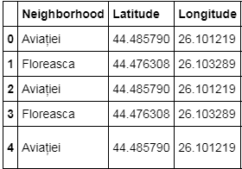

I will use populations of neighborhoods who has big population may need a new restaurant.

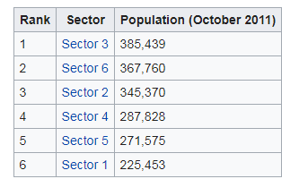 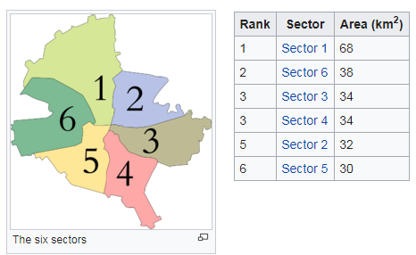

I will classify arrange neighborhoods by utilizing scenes dispersion and checks. Along these lines, I will discover likenesses of neighborhoods which will assist me with choosing area for opening another eatery. Comparable organized neighborhoods may deal with same kind of scene.

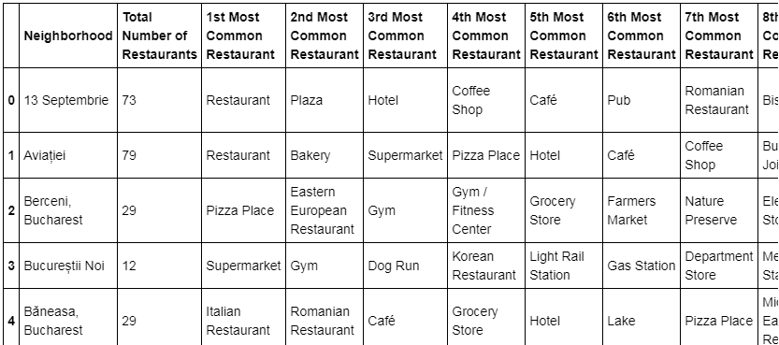

I will utilize scene list category to discover distribution of cafés and Turkish eateries in neighborhoods.

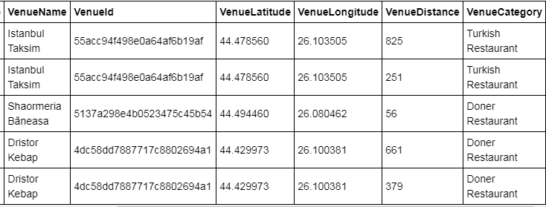

I will utilize likewise evaluations and preferences of cafés in the zones. It might assist me with finding area with awful appraising eateries which may require another eatery.

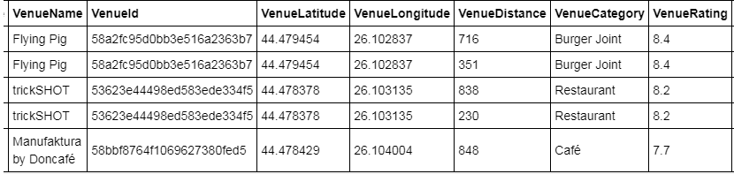

METHODOLOGY:

• I utilized GitHub storehouse for code forming.

• The Bucharest information is accessible with the local name in wikipedia. Area data (scope and longitude) of neighborhoods are taken from geocoder library.

• I took neighborhood from wikipedia and put blue specks on Bucharest guide to see focuses of neighborhoods. There are 40 neighborhoods in Bucharest

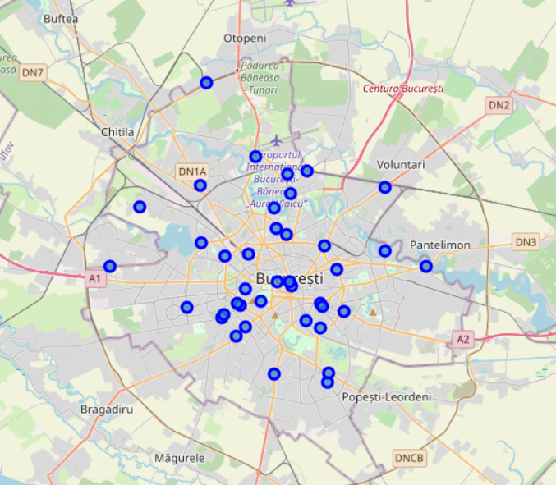

• I additionally got sector names of neighborhoods and populations of segments. There are 6 segments in Bucharest. I likewise consolidated Sector and Neighborhood information to find in which division neighborhood places.

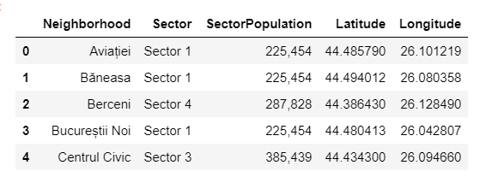

By utilizing Foursquare API I got settings 1 km around focus of every area with limit 100 scene. I combined information with Neighborhood information. Leader of the blended information is as beneath

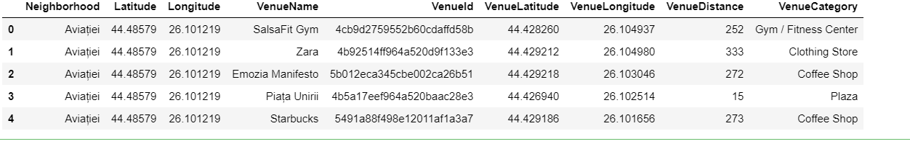

There are 56 unique venue categories in Bucharest and top 10 venue counts is as be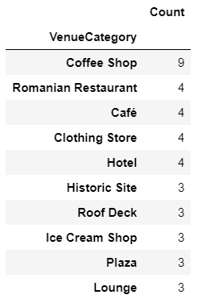

I filtered All restaurants and Turkish restaurant. Below is the histogram.

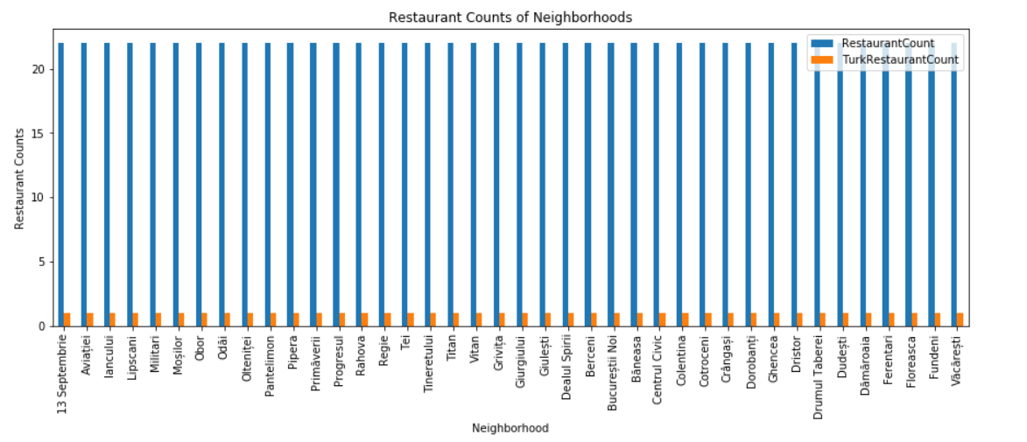

I used foursquare to get restaurant ratings by using venuid and merged with venue data

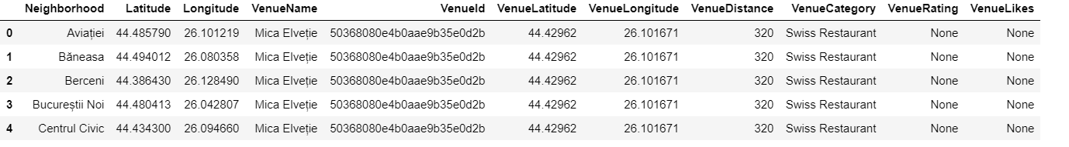

• I drew heatmap for includes of eateries in neighborhoods by utilizing Folium library. On heatmap, I likewise drawed 4 hardly any circles showing separation of 2km, 4km, 6km and 10km from Bucharest focus.

I superimposed Turkish cafés with red markers and blue markers as Turkish eateries with rating under 7 cafés on first map.I superimposed neighborhoods with no Turkish eatery with cyan markers in second heatmap

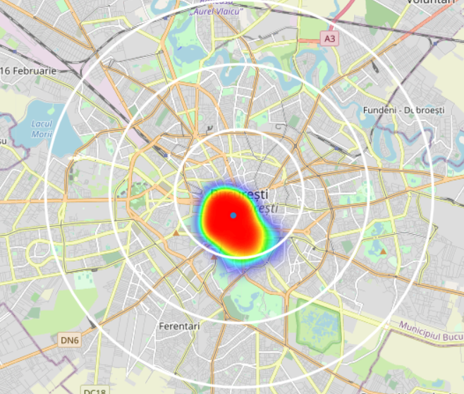

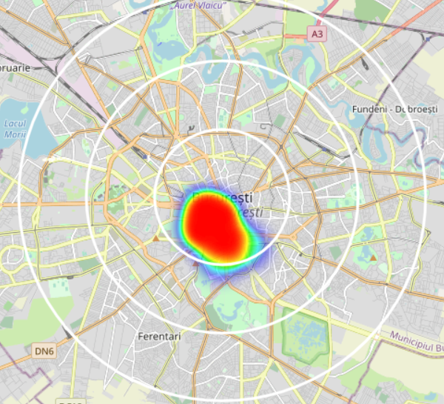

• I utilized Agglomerative Clustering to bunch neighborhoods as indicated by include of scene classifications in every area. As indicated by the underneath diagram, I chose to isolate our neighborhoods into 6 bunches (cut at separation of 20, even dark line).

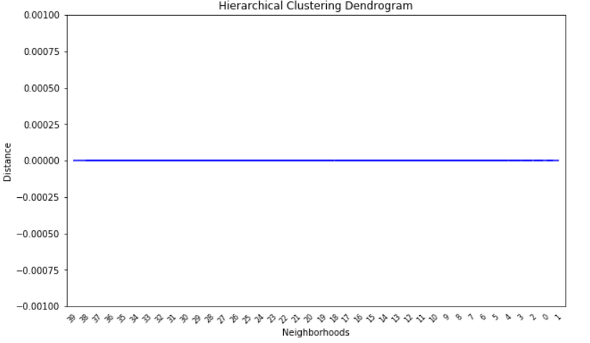

RESULTS:

I investigated that Turkish restaurant counts in Bucharest is 4.55%

* Total number of restaurants: 22
* Total number of Turkish restaurants: 1

CONCLUSION:

I have picked 3 areas for opening Turk eatery. The following are areas of neighborhoods. I trust this work will help someone who needs to open another Turkish eatery in Bucharest.

